Summary on Transfer learning:

========================

For obtaining better results we had followed the transfer learning method where we implemented 2 models

1. Transfer learning using Keras ResNet50 model trained with ImageNet dataset
2. Transfer learning using UNET model which we trained with the Pneumonia dataset

Transfer learning using Keras ResNet50 model

====================================

The model looks like below

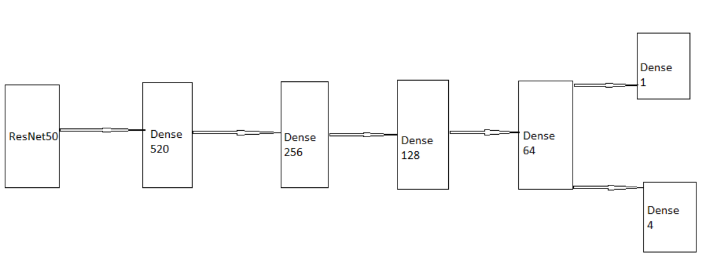

This is basically a sequential model with a ResNet50 model pre-trained with **‘ImageNet’** Dataset on the input side and 4 Dense layers.

The ResNet model layers were freezed in order to just use the learnings(weights) from ImageNet dataset, only the trainable layers were the Dense layers connected at the output of the ResNet layer.

**INPUT:**

* The Input for our model will be an image array of 128x128x3

**Output:**

* Same as for Our vgg model

**Loss Function:**

* Same as for Our vgg model

**Metrics:**

* Same as for Our vgg model

**Train and Validation sets:**

* Same as for Our vgg model

**Image Augmentation:**

* Same as for Our vgg model

**Model Summary:**

We can see there are Totally 40 million weights

But the Trainable parameters from the ResNet model which are 23 million are freezed.

The Dense layers contribute for around 17 million weights.

Model: "model"

__________________________________________________________________________________________________

Layer (type) Output Shape Param # Connected to

==================================================================================================

resnet50_input (InputLayer) [(None, 128, 128, 3) 0

__________________________________________________________________________________________________

resnet50 (Functional) (None, 4, 4, 2048) 23587712 resnet50_input[0][0]

__________________________________________________________________________________________________

flatten (Flatten) (None, 32768) 0 resnet50[0][0]

__________________________________________________________________________________________________

batch_normalization (BatchNorma (None, 32768) 131072 flatten[0][0]

__________________________________________________________________________________________________

dense (Dense) (None, 512) 16777728 batch_normalization[0][0]

__________________________________________________________________________________________________

batch_normalization_1 (BatchNor (None, 512) 2048 dense[0][0]

__________________________________________________________________________________________________

dropout (Dropout) (None, 512) 0 batch_normalization_1[0][0]

__________________________________________________________________________________________________

dense_1 (Dense) (None, 256) 131328 dropout[0][0]

__________________________________________________________________________________________________

batch_normalization_2 (BatchNor (None, 256) 1024 dense_1[0][0]

__________________________________________________________________________________________________

dropout_1 (Dropout) (None, 256) 0 batch_normalization_2[0][0]

__________________________________________________________________________________________________

dense_2 (Dense) (None, 128) 32896 dropout_1[0][0]

__________________________________________________________________________________________________

batch_normalization_3 (BatchNor (None, 128) 512 dense_2[0][0]

__________________________________________________________________________________________________

dropout_2 (Dropout) (None, 128) 0 batch_normalization_3[0][0]

__________________________________________________________________________________________________

dense_3 (Dense) (None, 64) 8256 dropout_2[0][0]

__________________________________________________________________________________________________

batch_normalization_4 (BatchNor (None, 64) 256 dense_3[0][0]

__________________________________________________________________________________________________

dropout_3 (Dropout) (None, 64) 0 batch_normalization_4[0][0]

__________________________________________________________________________________________________

activation (Activation) (None, 64) 0 dropout_3[0][0]

__________________________________________________________________________________________________

class_op (Dense) (None, 1) 65 activation[0][0]

__________________________________________________________________________________________________

reg_op (Dense) (None, 4) 260 activation[0][0]

==================================================================================================

Total params: 40,673,157

Trainable params: 17,017,989

Non-trainable params: 23,655,168

__________________________________________________________________________________________________

For Each Dense layer we have use a **dropout(0.4)** inorder to train better

The activation function used here is ‘relu’ except the output layer is using **sigmoid**.

**Result**:

* With all these steps we fit the model and ran it for 100 epochs and obtained the below accuracy for classification and regression.
  + Train Iou => , Validation Iou =>
  + Train_accuracy => , Validation accuracy =>

The model did not perform well with some amount of overfitting due to 17 million dense layer weights.

Even by using dropouts the performance did not improve much.

This is because the dense layers are not able to learn the neighbouring information of our image,

Only the convolution layers learn all the information about the image better.